These pages are property of From Yours To Mine, LLC and may not be copied or distributed, in whole or in part, without specific consent of From Yours To Mine, LLC. Copyright 2012. All rights reserved.

Working With The Inventory System

To start consigning with us you have to register for a consignor number. Choose the “Consign” link on our homepage and either choose “New Consignor Registration” from the drop down menu, or from the right side if you are already on the “Consign” page.

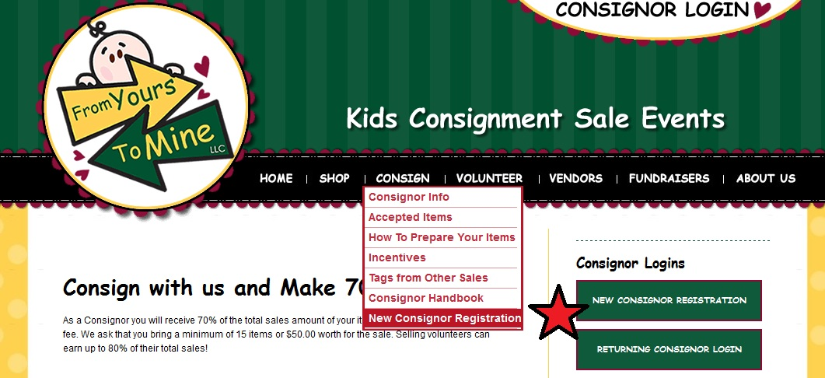
If you already have a consignor number, simply click the big “Consignor Login” button on the top right to log into your account.

After you have registered, or any time you log into your account, you will be taken to your “Consignor Homepage”. 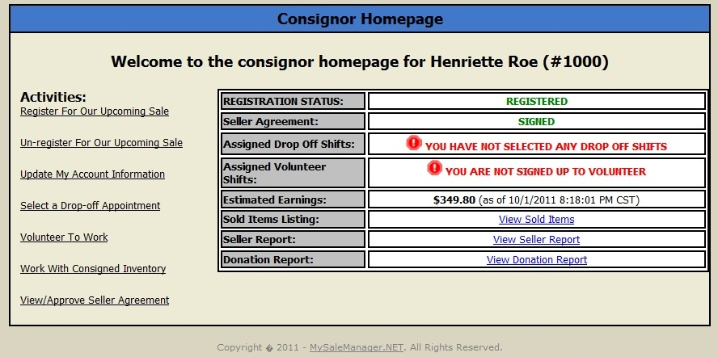
You can see different activities on the left, and information and status on the right. We will cover them all right here.

- Register For Our Upcoming Sale

You click this to register for the upcoming sale. It will take you to a page where you confirm your registration, and where you can read and electronically sign a copy of our Consignor Agreement. You can also find our Consignor Agreement at the end of this handbook.

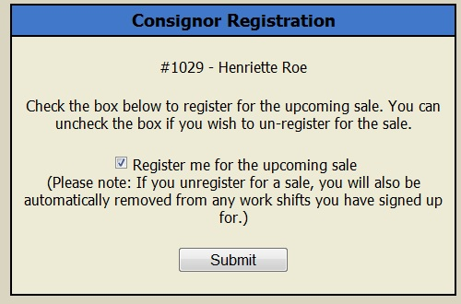

- Un-Register For Our Upcoming Sale

If you have registered for our sale but find that you can’t participate after all, here is where you can un-register yourself. We do ask that you please unregister as soon as you know that you won’t be participating.

- Update My Account Information

Did you move? New phone number? New email address? Here is where you can update your information to make sure we can communicate with you. Your consignment check will also be mailed to this address.

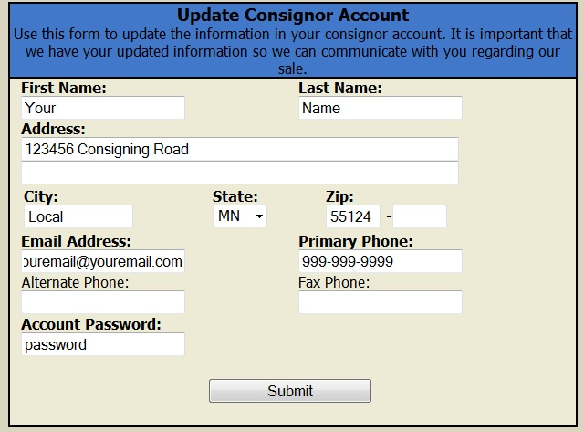

- Select a Drop Off Appointment

To minimize wait times for you during drop off we ask that you register for a time to drop off your items. Please read about drop off procedures and tips further down in this handbook.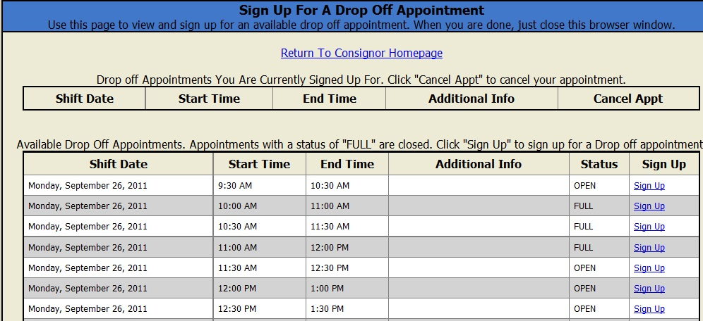

- Volunteer To Work

Here you can pick volunteer shifts if you want to help us during the sale. Please check the Volunteer section of this handbook for benefits and more information on volunteering.

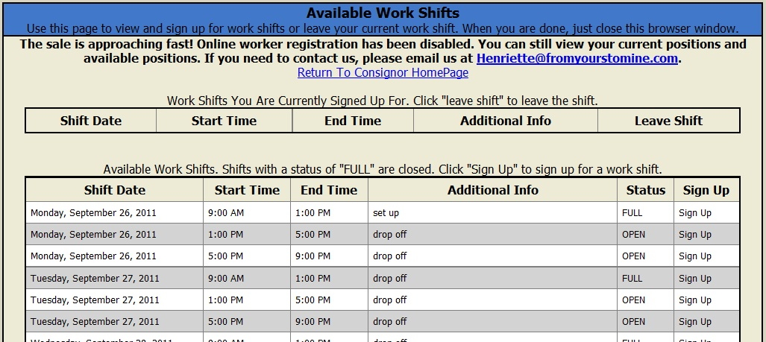

- Work With Consigned Inventory

We will cover this link at the end of this section as it has more options.

- View/Approve Seller Agreement

You can go here to review the Seller Agreement that you signed electronically when you registered for the sale.
To the right you see this information:

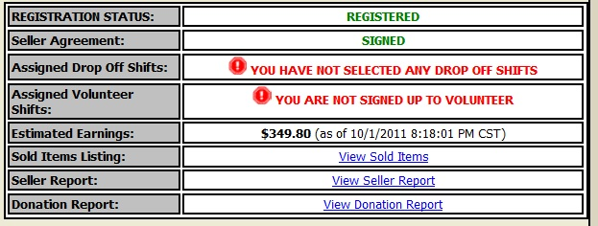

You can see if you are registered for the upcoming sale, the status of your seller agreement, and if you signed up for drop off or volunteer shift. If you did sign up for shifts, your shift information will be displayed here.

The Estimated Earnings are uploaded at least every night during the sale, sometimes more often. You can always check the time stamp to see how up to date the information is. Please note that the estimated earnings always default to a 70% consignor share minus a $10 registration fee. Any volunteer shift or other earning adjustments will be made manually, after the sale closes.

You can always check which of your items sold by clicking the Sold Items Listing, check and print your Seller Report which includes the Estimated Earnings total, and view and print your own Donation Report for your tax records. The Seller Report and Donation Report are not available until after the closing of our sale, and we always send out emails to alert you of any new reports that are posted.

But back to section 6 Work With Consigned Inventory. That is the link you click to enter or edit your consigned items. You will see this menu:

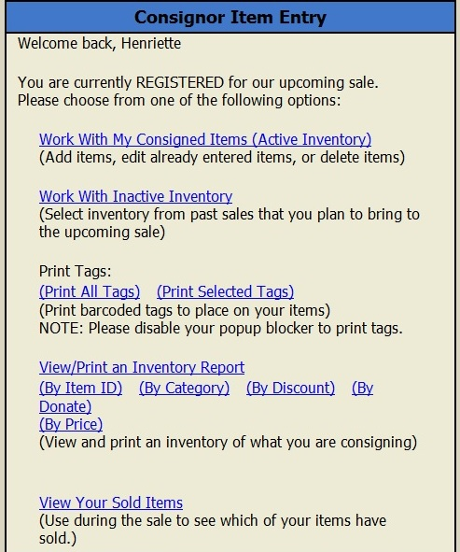

To add or edit items, click “Work With My Consigned Items”, the first link. You will get to the items entry screen that looks like this:

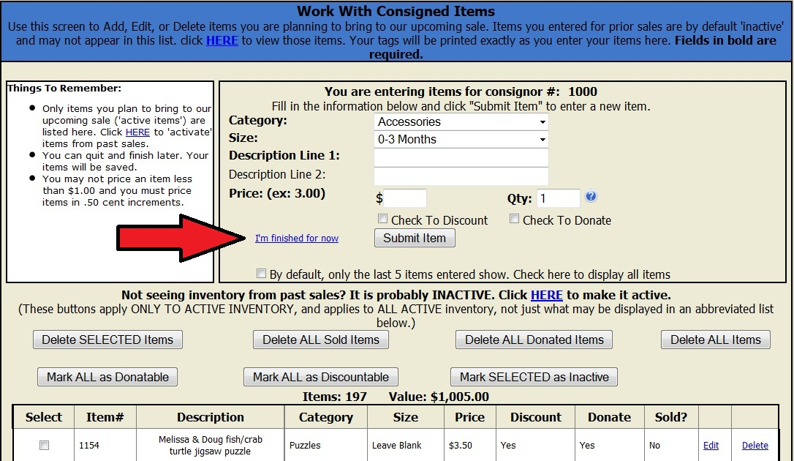

You can find information about pricing, description guidelines, and other helpful tips and tricks about your sales tags in the upcoming chapters. A few things to note are the option buttons below your item entry. Most of them are intuitive, but be careful with the “Delete ALL Donated Items” because hitting this button will delete ALL items that are marked with “donate Yes”. The system will not know when you entered these items and if they have been through a sale already. If you hit it after entering items for a new sale, the new items will be deleted if they are marked for donation.

And when you are all done entering items, click the really small “I’m finished for now” link next to the Submit Item button, marked here with a big red arrow. Clicking that button will get you back to the consignor homepage. You do not have to worry about saving items. Every item entered with the “Submit Item” button is saved into your inventory. You also want to click that link to get to the screen from where you can print your tags.

Use the Work with Inactive Inventory link to get to items entered for past sales, and select the ones that you are planning to bring to the upcoming sale, or delete items that you gave away or sold somewhere else. After each sale all unsold items left in your inventory will be marked “inactive”. This is done so only items that sellers plan to bring to the upcoming sale are “active”. This is important to us Sale Organizers so we can more accurately plan the sales floor and have a better count on how many items are coming in.

To print your tags you select either Print All Tags or Print Selected Tags. Print All Tags will automatically pop up a browser window with tags for all active inventory items. If you choose Print Selected Tags, you can choose to only print tags for items not previously printed, or select specific individual tags to print. More information and tips on printing your tags is discussed further down in this handbook.

You can also View/Print an Inventory Report of your active items at any time. There are different options to sort that report for you.

The last report called View Your Sold Items is the same report as the one you can see from your Consignor Homepage.
You can print tags at any time. I personally prefer to work on a stack of items at a time. For example, I gather 20 to 30 clothing items, enter them all, print tags for those, attach those tags, and put the items in my "done" corner. Next time when I have time I grab 10 or 20 toys and do the same thing. Some consignors prefer to enter all their items, then print all the tags at once. I personally find it too overwhelming to sort through 150+ tags trying to find the one that goes with each outfit or item. The first version also has the benefit that you can focus on the most important items you want to sell first, and get them ready to go. If you run out of time and don't get all your items tagged, you at least have some that you can sell, and the rest can wait until the next sale.

